When you use Ambari's File View to upload data and then use Hive View to query that data without explicitly writing the CREATE TABLE command, Ambari indeed handles the table creation in the background. Here's a more detailed explanation:
How Ambari Simplifies Data Management
Apache Ambari is a management platform for provisioning, managing, and monitoring Apache Hadoop clusters. It provides a web-based interface that simplifies many of the tasks associated with managing Hadoop services.
Steps Involved:
- Uploading Data Using Ambari File View:
  - You upload your data files (e.g., CSV, TSV, JSON) to HDFS using the Ambari File View interface.
  - This interface allows you to navigate the HDFS file system, upload files, and manage directories.
- Creating Tables in Hive View:
  - When you navigate to the Hive View after uploading your data, Ambari provides options to create Hive tables based on the uploaded files.
  - You may not need to write the CREATE TABLE command manually. Instead, Ambari guides you through a wizard where you specify details like the file format, delimiters, and column names.
- Automatic Table Creation:
  - Ambari uses the information you provide in the wizard to generate the appropriate CREATE TABLE command.
  - It then executes this command in the background to create a Hive table that maps to the data file you uploaded.
Example Scenario
- Upload Data:
  - You upload a CSV file called ratings.csv to HDFS at the location /user/maria_dev/ml-100k/ratings.csv using Ambari File View.
- Define Table Structure in Hive View:
  - In Hive View, you are prompted to create a new table.
  - You specify the table name, data file location, and column details (e.g., userID INT, movieID INT, rating INT, ratingTime INT).
  - Ambari generates the following CREATE TABLE command based on your input:
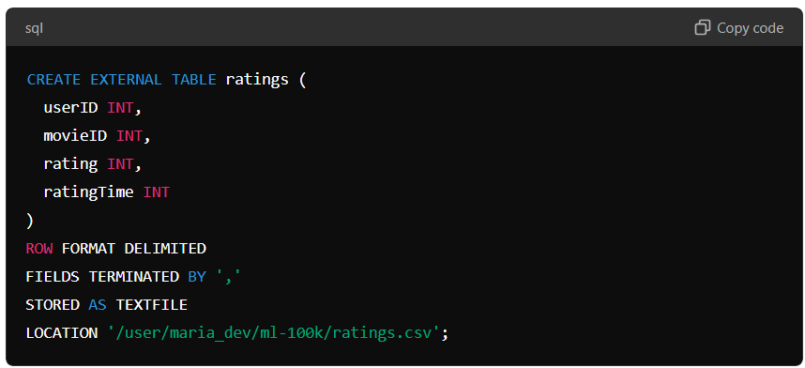
CREATE EXTERNAL TABLE ratings (
userID INT,
movieID INT,
rating INT,
ratingTime INT
)
ROW FORMAT DELIMITED
FIELDS TERMINATED BY ','
STORED AS TEXTFILE
LOCATION '/user/maria_dev/ml-100k/ratings.csv';
- Table Creation:
  - Ambari executes this command in the background, creating the ratings table in Hive.
- Querying Data:
  - You can now query the ratings table using Hive View without manually writing the CREATE TABLE statement.
Benefits of Using Ambari for Table Creation
- Ease of Use: Ambari provides a user-friendly interface that abstracts the complexity of Hive table creation.
- Consistency: Ensures that the table structure matches the data file format, reducing the likelihood of errors.
- Efficiency: Saves time by automating the table creation process.
Conclusion
When you use Ambari File View to upload data and then use Hive View to query that data, Ambari indeed creates the necessary Hive tables in the background. This feature simplifies the process of ingesting and querying data in Hive, making it more accessible to users who may not be familiar with writing HiveQL commands. Ambari's automated handling of table creation ensures that the data is correctly mapped and ready for analysis.

